

**Fatima Jinnah Women University**

**Submitted to: Sir Adeel Khalid**

**Submitted by: AimenJillani (001)**

**Kainat Bibi (017)**

**Maryam Siddiqui (027)**

**Natasha Kanwal (032)**

**Noor Fatima (035)**

**Wishma Noor (041)**

**Course: Artificial Intelligence**

**Semester/Department: BCS (6thSemester)**

**Table of Contents**

Introduction 3

Computer Vision 3

Objectives 3

Methodology: 4

Dataset 5

Technical Framework 5

Implementation Steps: 5

Algorithm 5

Cnn Architecture 5

Key 6

Functionality 6

Learning 6

Automated 6

Importance: 6

Expected Outcomes: 6

Code Description 7

Applications: 8

Conclusion: 9

References: 11

**Project Proposal: Gender and Age Detection using Deep Learning**

## **INTRODUCTION**

The **"Gender and Age Detection"** project employs Deep Learning to classify gender and age from facial images using pre-trained models by **Tal Hassner** and **Gil Levi**. It categorizes gender as 'Male' or 'Female' and **age into predefined ranges**, acknowledging the **inherent variability in facial features**. This project showcases the **fusion of computer vision and Deep learning, offering practical insights into real-world applications**

Facial recognition technology has rapidly evolved, offering new possibilities for understanding human demographics and behavior. In this proposal, we aim to explore the application of gender and age detection from facial images in various domains, leveraging cutting-edge deep learning techniques.

## **COMPUTER VISION**

Computer Vision enables computers to **interpret digital images and videos** similarly to humans. It involves **acquiring, processing, and analyzing visual data to extract meaningful information for decision-making**. Challenges arise from the complexity of replicating human vision. Key tasks include **object recognition, video tracking, motion estimation, and image restoration.**

## **OBJECTIVES**

The primary objective of this project is to create a sophisticated deep learning model capable of accurately predicting the age and gender of individuals from facial images. Specific goals include:

1. **Dataset Collection:** Curate a comprehensive dataset of facial images with age and gender annotations from sources pre-trained models by **Tal Hassner** and **Gil Levi** Face datasets. Ensure the dataset is diverse and representative of various age groups, genders, and ethnicities.
2. **Data Preprocessing:** Normalize and augment the dataset to **enhance diversity and reduce biases**. Apply techniques such as rotation, flipping, and resizing for standardization. **Remove noise and irrelevant features** to improve model performance.
3. **Model Development:** Design and implement **CNN architectures for age and gender classification using frameworks like TensorFlow or PyTorch**. Experiment with different network architectures, activation functions, and optimization algorithms to achieve optimal performance.
4. **Training and Evaluation:** Train the models on the preprocessed dataset using stochastic gradient descent optimization and cross-entropy loss minimization. Evaluate model performance on a separate test set to measure accuracy, precision, recall, and F1-score. Implement techniques such as regularization, dropout, and data augmentation to improve generalization and mitigate overfitting.
5. **Real-time Analysis:** Implement **real-time video processing using OpenCV for face detection and classification**. Integrate the trained models into the pipeline for dynamic analysis of age and gender distribution. Ensure efficient processing and low latency for real-time applications.
6. **Deployment:** Develop web or mobile interfaces for seamless integration of the model into various applications. Ensure user-friendly interfaces for intuitive usage and provide documentation for developers. Deploy the model on cloud platforms or edge devices for scalability and accessibility.

## **PURPOSED METHODOLOGY**

* **Data Collection and Preprocessing**: We will gather a **diverse dataset of facial images**, ensuring representation across different demographics and environments. Data preprocessing techniques will be employed to standardize image size, orientation, and quality, enhancing model performance.
* **Model Development**: Utilizing **convolutional neural networks (CNNs)**, we will develop models capable of **automatically learning relevant features for gender and age detection from facial images**. Training will be conducted using techniques like data augmentation to improve model robustness.
* **Evaluation:** Model performance will be evaluated using **standard metrics such as accuracy, precision, recall, and F1-score.** We will validate the models on test datasets to assess their generalization capabilities.

The work flow of the proposed age and gender predictor is

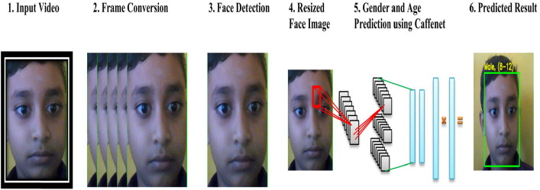

## 

## **DATASET**

The Python project utilized the Adience dataset, **comprising over 26,000 facial photos of approximately 2,000 individuals**. This dataset encompasses diverse real-world conditions like lighting and poses. Trained on Adience, the project's models accurately predict gender and age from facial images.

## **TECHNICAL FRAMEWORK**

* **OpenCv** The purpose of OpenCV is for **image processing and computer vision tasks within the Python project.**
* **argparse** The purpose of argparse is to **handle command-line arguments passed to the Python script, making it easier to parse and process user inputs.**
* **TensorFlow** is a popular **open-source machine learning framework developed by Google**. It's known for its flexibility, scalability, and comprehensive ecosystem, making it suitable for building and deploying machine learning models across various platforms.

## **IMPLEMENTATION STEPS:**

* **Face Detection**: Use pre-trained TensorFlow model to identify faces.
* **Age and Gender Prediction**: Employ separate models for gender and age estimation, trained on Adience dataset.
* **Integration**: Combine components into user-friendly application for image or video input.

## **ALGORITHM**

* **Algorithm:** Utilize Convolutional Neural Network (CNN).
* **Training:** Train CNN on Adience dataset.
* **Purpose:** Recognize patterns for age and gender classification.

## **CNN ARCHITECTURE**

**CNN** **Basics**:

CNNs are specialized neural networks used in Computer Vision tasks within AI, designed to interpret visual information like images.

KeyComponents:

* **Input Layer**: Receives raw data, often pixels from images.
* **Hidden Layers**: Consist of Convolutional, Pooling, and Fully Connected layers.
* **Output Layer**: Produces final predictions, often using softmax for classification tasks.

Functionality:

* **Convolutional Layers:** Detect important features like edges in images.
* **Pooling Layers**: Simplify information by reducing dimensionality.
* **Fully Connected Layers:** Make final decisions based on extracted features.

Learning Process:

CNNs use feedforward to pass data through layers and adjust weights through backpropagation to minimize errors.

CNNs automatically find important patterns in data, eliminating the need for manual feature selection.

# Importance:

CNNs are crucial for accurate image and video analysis in modern AI applications due to their ability to handle complex visual tasks effectively.

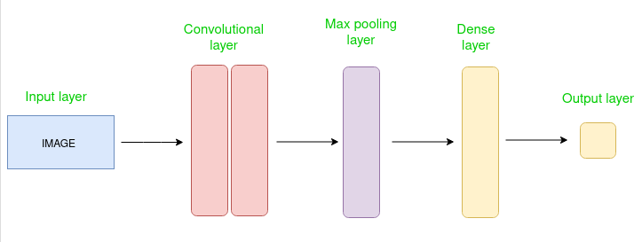

## 

## **EXPECTED OUTCOMES:**

Upon successful completion of the project, the following outcomes are anticipated:

* **Accurate Age and Gender Prediction:** Development of a deep learning model capable of accurately predicting the age and gender of individuals from facial images.
* **Real-time Video Processing:** Demonstration of real-time video processing for dynamic analysis of age and gender distribution in live video streams.
* **Practical Deployment**: Deployment of the model via accessible interfaces for practical applications in security systems, entertainment, and social media analysis.
* **Contribution to Research:** Contribution to the advancement of computer vision techniques in age and gender detection, with potential implications for diverse fields.

## **CODE DESCRIPTION**

This Python code implements a gender and age detection program using deep learning techniques and OpenCV library. Let's break down the key components and describe the techniques and libraries used:

**1. Deep Learning Techniques:**

* The program utilizes deep learning models trained for face detection, gender classification, and age estimation.
* These models are implemented using Convolutional Neural Networks (CNNs), which are a class of deep neural networks commonly applied to image analysis tasks.

**2. Libraries Used:**

* OpenCV (cv2): OpenCV is an open-source computer vision and machine learning library. It provides various functionalities for image and video processing, including face detection and deep neural network inference.
* Argparse: The argparse module provides an easy way to parse command-line arguments and options. It allows users to specify input images or video streams through command-line arguments.

**3. Face Detection Model:**

* The program uses a pre-trained face detection model provided by OpenCV. The model is loaded from two files: "opencv_face_detector.pbtxt" (which contains the graph definition) and "opencv_face_detector_uint8.pb" (which contains the trained weights).

**4. Gender and Age Classification Models:**

* + Separate pre-trained models are used for gender and age classification. These models are implemented using deep neural networks and trained on large datasets.
  + For gender classification, the program loads the model from "gender_deploy.prototxt" (configuration file) and "gender_net.caffemodel" (trained weights).
  + For age estimation, the program loads the model from "age_deploy.prototxt" (configuration file) and "age_net.caffemodel" (trained weights).

**5. Image and Video Processing:**

* + The program captures frames from either a live video stream (webcam) or an input image specified via command-line arguments.
  + It processes each frame to detect faces using the face detection model. Detected faces are then cropped and passed to the gender and age classification models for inference.

**6. Output Display:**

* The program annotates each detected face with predicted gender and age information.
* It displays the annotated image in a window titled "Detecting age and gender".

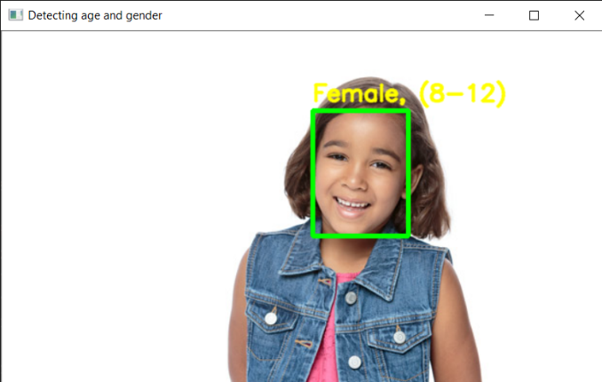

Overall, this program demonstrates the integration of deep learning models for face detection, gender classification, and age estimation, enabling the automated analysis of gender and age from facial images or video streams. It showcases the capabilities of deep learning in computer vision tasks and the utility of libraries like OpenCV for implementing such applications.

## **APPLICATIONS:**

* **Security and Surveillance**: Enhance access control and monitor individuals in public spaces.
* **Marketing and Advertising**: Tailor advertisements based on demographic information obtained from facial analysis.
* **Healthcare:** Analyze patient demographics for personalized healthcare services and medical research.
* **Entertainment:** Provide personalized content recommendations and interactive experiences.
* **Retail:** Analyze customer demographics for targeted product recommendations and store layout optimization.
* **Education:** Customize educational content and resources based on student demographics and preferences.
* **Human Resources**: Streamline recruitment processes by analyzing candidate demographics and assessing workforce diversity.
* **Social Media:** Enhance user experience by providing personalized content and targeted advertisements.

## **CONCLUSION:**

The proposed project aims to leverage deep learning techniques to address the challenges associated with age and gender detection from facial images. By combining state-of-the-art CNN architectures with real-time video processing capabilities, the project seeks to deliver a robust and versatile solution applicable across various domains. Through meticulous dataset curation, model development, and deployment, the project endeavors to contribute to the advancement of computer vision technologies and their practical applications.

https://www.geeksforgeeks.org/python-programming-examples/https://www.geeksforgeeks.org/python-programming-examples/https://www.geeksforgeeks.org/python-programming-examples/https://www.geeksforgeeks.org/python-programming-examples/https://www.geeksforgeeks.org/python-programming-examples/

## **REFERENCES:**

* <https://www.sciencedirect.com/science/article/pii/S2214785320362222#b0030>
* <https://www.kdnuggets.com/2019/04/predict-age-gender-using-convolutional-neural-network-opencv.html>
* <https://www.geeksforgeeks.org/age-and-gender-prediction-using-cnn/>
* <https://medium.com/@skillcate/gender-detection-model-using-cnn-a-complete-guide-279706e94fdb>